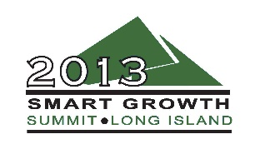
Breakfast Plenary Session

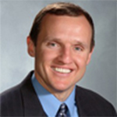
Kenneth Daly – National Grid
Kenneth D. Daly, CFA, is the president of the New York business of National Grid, which serves 4 million electric and natural gas customers throughout Long Island, Queens, Staten Island, Brooklyn and upstate New York.
Daly joined National Grid’s predecessor, Brooklyn Union, which later became KeySpan, in 1988 as a management trainee in the Customer Relations Department. He was recently based in London, serving for 2 years as group financial controller, and held numerous positions in Finance, Human Resources and Customer Relations throughout his 25 year-career.
Daly graduated from St. Francis College in 1988, before attending St. John’s University and Polytechnic University for two master’s degrees. He earned the distinguished Chartered Financial Analyst designation in 2002.
Daly is also a member of the Saint Francis College Board of Trustees and has been an adjunct professor at SFC, teaching human resource, business and finance courses for 20 years. He has been the director of the St. John’s University Executive-in-Residence Program since 1992. He is the past chairman of the Kingsborough Community College Board of Directors and a former member of Junior Achievement Board of Directors and United Way Campaign co-chair. The president is also a member of the David Rockefeller ‘Fellows Program,’ the Long Island Energeia Partnership, the British American Business Council Board and Advanced Energy Research and Technology Center Board.

