
Brownfields Boom or Bust?


Keith Samaroo – Paulus, Sokolowski & Sartor, Moderator
Keith Samaroo is an associate principal at Paulus, Sokolowski & Sartor, responsible for managing the New York Offices on Long Island and Yonkers. He has more than 15 years of experience working in the private real estate development and corporate markets. Samaroo is responsible for the sales of engineering services within the real estate markets including Brownfields, Waterfront and Urban Infill redevelopment projects, as well as managing clients, and coordinating and preparing cost proposals. He also coordinates the efforts of all involved disciplines to ensure client milestones are achieved. Samaroo is also responsible for developing relationships with municipalities and governing agencies to help streamline the approval process of projects.
He is an officer and sits on the Board for US Green Building Council (LI Chapter), Board of Director for Big Brothers Big Sisters, Chairman of Trustees for United Methodist Church, Alumni of LIBN “40 Under 40” Award.
Samaroo has a bachelor’s in Physics from Fordham University, Equivalent Electrical Engineering from Manhattan College, and a master’s in Banking & Finance from Dowling College.

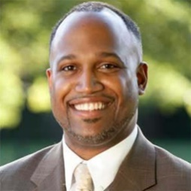
DuWayne Gregory – Suffolk County Legislature
In 2011, DuWayne Gregory became the first person of color to be elected majority leader in the history of the Suffolk County Legislature. In this role Gregory leads the 13-member Democratic Caucus which has controlled the legislature since 2006.
A native Islander, he enlisted in the Army in 1993. Soon after, he was accepted to Officer Candidate School (OCS). After completion of OCS, Lieutenant Gregory was commissioned as a 2nd Lieutenant in field artillery.
In 2000, Gregory was appointed under Babylon Supervisor Rich Schaffer as the town’s citizen’s advocate. After Steve Bellone succeeded Schaffer, he appointed the veteran to become the town’s deputy commissioner for Public Works. In 2002, Bellone promoted Gregory to commissioner of General Services. In 2004, Gregory went on to work for the Suffolk Off-Track Betting Corporation, leaving in 2007 as the associate director for Corporate Services to work as the chief of staff to former County Legislator Elie Mystal.
First elected to the Suffolk County Legislature via special election in 2008, Gregory has defended his seat three times. Since 2009, he has served as chair of the Legislature’s Budget & Finance Committee. The legislator was appointed to the Advisory Council on Procurement Lobbying by Speaker of the New York State Assembly Sheldon Silver in 2005. He was once a member of the Route 110 Redevelopment Corporation.
Gregory holds a Bachelor of Arts degree in Justice and Public Policy from North Carolina Wesleyan College.
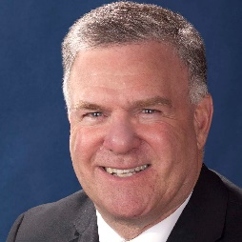
Mitchell H. Pally – Long Island Builders Institute
Mitchell H. Pally is the CEO of the Long Island Builders Institute. The largest home building trade association in New York, the organization represents all facets of the home construction industry.
Prior to his current position, Pally was the partner in charge of government relations for the Weber Law group, one of Long Island’s leading real estate law firms.
He had also served as the vice president for Governmental Affairs with the Long Island Association (LIA) since January 1992, responsible for all governmental and community activities. LIA is the region’s largest business and civic organization with more than 3,000 member firms employing more than 400,000 people.
Prior to his service with the LIA, Pally held a number of positions in the New York State Legislature. From 1975-1983, he served in the New York State Senate Committee on Transportation and the Legislative Commission on Critical Transportation Choices, and between 1983-1985 he was the chief counsel to the Committee and the Commission. During his time with the Senate, Pally played a key role in the drafting and passage of important transportation legislation like the first in the nation seatbelt law, child restraint law, the Transportation Bond Issues of 1983 and 1979, and reserved parking spaces for disabled drivers.
Over the years, the CEO has held countless positions and memberships with organizations across Long Island. That includes roles with workforce housing coalitions, MTA Board, open space councils, boards of education and the League of Conservation Voters.
Pally graduated SUNY Cortland and holds a law degree from the Albany Law School of Union University. He taught Political Science at Stony Brook University between 1989-2008, and now teaches at Suffolk County Community College.

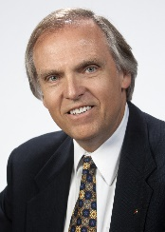
Gary Rozmus – GEI Consultants
Gary Rozmus is a senior consultant with GEI Consultants with 38 years of experience in the environmental consulting services field. He has been involved in the Brownfield/contaminated site redevelopment marketplace for many years and worked on a wide variety of Brownfield projects for private and public clients both locally and nationally. Gary has been involved in eight projects conducted under Brownfield Opportunity Area (BOA) grants.
Rozmus was the first chairman of the Board of Directors for the New York City Brownfield Partnership and still serves on the board. He helped develop the New York State Chapter of the National Brownfield Association, serving on the Executive Team and as Environmental Committee Co-Chair. He also served on the National Brownfield Association National Advisory Board.
Rozmus directs a broad range of environmental services including site investigations and remediation; pre-purchase/pre-sale assessments and due diligence; infrastructure project environmental services; environmental compliance and permitting; and facility decommissioning and demolition. He also provides litigation-related services to his clients and attorneys.
He is located in GEI’s Huntington Station office. The firm provides a broad array of geotechnical, environmental, water resources, ecological science and engineering consulting services.

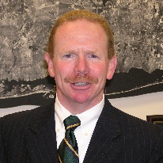
Peter Scully – NYS Department of Environmental Conservation
Peter Scully was appointed regional director of the New York State Department of Environmental Conservation in June 2003. He is responsible for oversight of all state environmental programs on Long Island, ranging from open space acquisitions to regulation of solid and hazardous waste facilities and stocking of trout in local waterways.
Scully also serves as the governor’s representative on the Central Pine Barrens Joint Planning and Policy Commission, which elected him as its chairman in February 2004.
Prior to his role as a DEC director, Scully served in a number of important executive level positions in local government on Long Island, including: deputy Suffolk County executive and Suffolk County parks commissioner; commissioner of Environmental Control in the Town of Islip; and deputy supervisor of the Town of Brookhaven.
Scully earned both his bachelor’s and master’s degrees at SUNY Stony Brook. He and his wife live in Stony Brook, where he has served the community as chairman of the Brookhaven Conservation Advisory Council, president of the Civic Association of the Setaukets, and as a member of the Three Village Board of Education.

