
Complete Streets

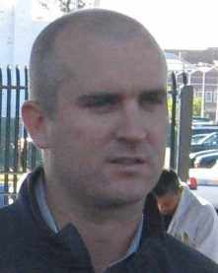
Ryan Lynch – Tri-State Transportation Campaign, Moderator
Ryan Lynch has served as Tri-State's associate director since July 2012. In this capacity, he assists in overall management, strategic planning and messaging, and key policy decisions. Lynch joined the Campaign in October 2007 as a senior planner, where he also served as its Long Island and Connecticut coordinator. In January 2012, he was promoted to policy director, where his advocacy for sustainable transportation policy, better transit systems, and complete streets for all users broadened to the tri-state region.
Prior to joining the campaign, Lynch worked along the Thai-Burma border as an alternative livelihoods specialist for Women's Education for Advancement and Empowerment. He also worked as the associate forest planner for the Wisconsin Department of Natural Resources and as a policy intern with Oxfam America. The associate director began his career in community development and advocacy as a Peace Corps volunteer in West Africa. Currently, Lynch serves on Brooklyn Community Board 7 and is chair of Brooklyn Borough President Marty Markowitz's Transportation, Traffic and Safety Committee for the Fourth Avenue Task Force.
Originally from Long Island, Lynch attended the University of Wisconsin-Madison, where he earned a Masters in Urban and Regional Planning with a concentration in International Development Planning and foci in Economic and Environmental Development. He graduated from Mary Washington College.

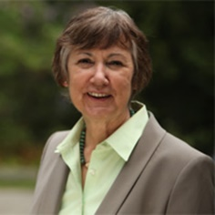
Connie Kepert – Town of Brookhaven
Councilwoman Connie Kepert was elected to the Brookhaven Town Council in November of 2005. Prior to being elected, Kepert served as president of the Affiliated Brookhaven Civic Organization, Longwood Alliance and Middle Island Civic Association over a period of 18 years. As a civic leader, she concentrated on solving problems through a participatory process that brings people together, and encourages the building of a community vision.
Kepert has pressed for policies that encourage sustainable development, steer development away from sensitive sites and into centers, and create people oriented, equitable places. She led the effort that resulted in a four-day charrette along the Middle Country Road corridor.
For her hard work and dedication, Kepert received the American Planning Association's 2010 National Planning Leadership Award for a Planning Advocate, North Shore Sun’s 2007 Public Servant of the Year Award, Open Space Council Dennis Puleston Conservation Award, Brookhaven Town Women of the Year Award, Suffolk County Volunteer of the Year Award, Paumanok Bike Club Recognition, PTA Distinguished Service Award, Woman of the Year Award from the Times Beacon Record and a Paumanok Bike Club Recognition award for her work. She was also honored with Vision Long Island’s Community Leadership Award. Connie was designated a Paul Harris Fellow by the Middle Island Rotary and recognized by the L.I. Progressive Coalition as a “Long Islander who has Made a Difference.”
Kepert graduated from SUNY Oneonta, earned her master’s in Public Policy from the University of Oregon and holds teaching certifications from Dowling College in both Social Studies and Special Education. She teaches at Longwood High School.

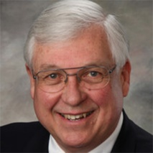
Jim McLaughlin – Wendel Companies
Jim McLaughlin is a Senior Transit Planner for Wendel.
Wendel is a nationally-recognized multi-disciplinary firm including architecture, engineering, planning, energy and construction management services with more than 70 years in the public transportation industry.
As project manager for comprehensive transit projects, his engagements include a variety of planning efforts, such as management performance reviews, short and long range transit plans, regional coordination and consolidation recommendations and ADA paratransit and human service transportation coordination.
McLaughlin has both public and private sector experience, serving as the director of Transit Planning for the Los Angeles County Metropolitan Transportation Authority, in charge of a diverse projects such as the Metro Rapid BRT program, planning for the Universal Fare System, and communication with municipal, local and private sector operators, as well as for the City of Los Angeles Department of Transportation as its initial chief of Transit Programs and implemented local shuttle, commuter express and community transportation programs for the city, including preparing budgets, securing grants, working with community representatives and local officials. He also has 10 years of experience in consulting assignments.
McLaughlin is a member of the American Public Transportation Association, Community Transportation Association of America and Transportation Research Board.
He graduated with a bachelor’s in Civil Engineering from Newark College of Engineering in 1978.

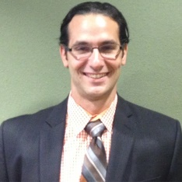
Ryan Russo – NYC Department of Transportation
Ryan Russo is an assistant commissioner at the New York City Department of Transportation. Russo has been with the department since 2003, where he manages planning and operational offices responsible for pedestrian safety programs and projects, bicycle network development, traffic planning, sign manufacture and installation, geometric design and maintenance of roadway markings. From 2006-2009, Russo oversaw the expansion of NYC's bicycle network by 200 miles in a 36 month period. He concurrently managed numerous pedestrian-oriented street reconfigurations, including the design, implementation and evaluation of the "Green Light for Midtown" project that closed portions of Broadway to vehicular traffic, creating pedestrian plazas at Times and Herald Squares while improving motor vehicle traffic flow. In 2010, Russo guided NYC’s landmark Pedestrian Safety Study and Action Plan which refocused the City’s safety program to high crash arterial corridors, many of which have since been reengineered using an innovative rapid implementation toolkit.


David Sabatino – Envision Valley Stream
David Sabatino, a resident of Valley Stream, is the founder of a community organization, Envision Valley Stream (EVS). Together with residents, businesses and other groups, EVS works to develop a shared vision for the future of the community. Sabatino formed EVS in 2009 while he was attending NYU, where he received his master’s degree in Urban Planning.
Sabatino has been a member of the Valley Stream Chamber of Commerce since 2011. He became a board member in 2013. In addition to his role in the Chamber, he’s been active in many other civic activities, such as the Civilian Patrol and the Board of Zoning Appeals. He is also a founding member of the Valley Stream Dog Park.
Currently, Sabatino is the co-owner of Sip This, a coffeehouse in Valley Stream. Together with his business partner, Stephanie Pontillo, he created a unique place where the community can have a delicious cup of coffee while enjoying music and art. In 2012 David married his wife, Sarah. Together they recently purchased a home in Valley Stream.
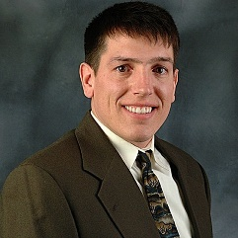
Will Stoner – AARP New York
Will Stoner, AARP associate state director for Livable Communities, is responsible for the organization’s “Livable Communities” agenda in New York State, which includes housing, mobility, and coordination of services. He has worked closely with community partners from across the state to assess the challenges that older New Yorkers are facing in safely navigating their streets and to develop strategies to ensure that residents of all ages and abilities can remain living at home and in their communities.
Stoner’s expertise is in community engagement, organizing, and advocacy at all levels of government. His career began in western New York where he worked for an environmental lobby organization. In 2002, he moved to Long Island and began working for the American Cancer Society. He is most proud of the work for age friendly communities that lead to the law in Suffolk and Westchester Counties requiring that affordable housing be built with Inclusive Design Standards and local level complete streets’ policies in towns across the island and a statewide Complete Streets law.
He is a graduate of Canisius College and has a master’s from Stony Brook University.

