
Education’s Role In Rebuilding Our Downtowns
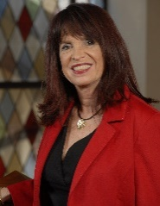
Elana Zolfo – Dowling College, Moderator
Dr. Elana Zolfo is currently the dean of the School of Business of Dowling College. Before taking this position, she was appointed interim president and provost, and continued in her role as vice president of Corporate Programs and Continuing Education. From 2006-2008, Zolfo served as the interim president of Dowling College and senior vice president. Prior to joining Dowling College in 1993, Zolfo worked for Suffolk County Community College as assistant dean in charge of the Technicenter.
Zolfo’s career in higher education began 36 years ago in Nassau Community College. She continued to work in the Evening Advisement Center and teach as an adjunct professor until 1993. Her passion for education is a result of the experience she had as a student in Nassau Community College.
With her extensive background and experience in both the educational and corporate communities, she is able to develop and enhance educational partnerships between Dowling College and major organizations such as Federal Express, National Grid, Broadbridge, various credit unions, Estee Lauder and A& Z Pharmaceuticals, to name a few.
Zolfo is the Chair of (HIA-LI) Board of Directors and a member of Women Economic Developers of Long Island. She is an active leader involved with Vision Long Island and several other organizations. Zolfo is proud to be a board member of the American Heart Association and a committee member of United Cerebral Palsy.
Zolfo holds an A.A.S from Nassau Community College, B.A. in Psychology from Hofstra University, M.B.A. from Adelphi University and a Doctorate in Educational Administration from Dowling College.

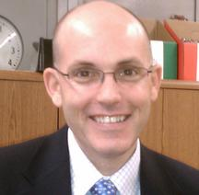
Kenneth R. Bossert – Port Jefferson Union Free School District
Kenneth R. Bossert is the superintendent of schools in the Port Jefferson Union Free School District, traditionally ranked as one of the top school districts in New York State.
A lifelong educator, Bossert has also served in the capacity of assistant superintendent for Curriculum and Instruction in the Three Village Central School District, elementary principal in the Eastport/South Manor Central School District, assistant principal in the Longwood School District, and elementary classroom teacher in the Middle Country Central School District.
A St. Joseph’s College graduate, Bossert completed both his master’s and advanced graduate degrees at SUNY Stony Brook University, and his doctorate at Dowling College in 2008.

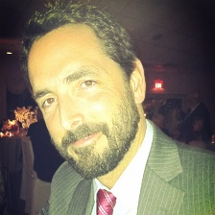
Michael Hynes – Shelter Island School District
Dr. Michael Hynes is the superintendent of the Shelter Island School District. Prior to working in Shelter Island, Hynes worked for the Plainedge School District as the assistant superintendent for Curriculum and Instruction, elementary principal for the Center Moriches School District and middle school principal for the South Country School District.
Raised in Sayville, Hynes graduated from Bethany College in West Virginia. He received his master’s degree in Elementary Education, his Professional Diploma in School District Administration and doctorate in Educational Administration from Dowling College. The administrator also received his educational training from New York University, Stony Brook University and Harvard University in the areas of School Leadership, School Business Affairs and Organizational Learning.

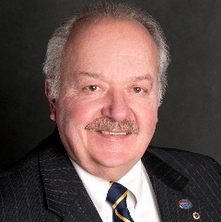
John Lombardo - Suffolk Community College
John Lombardo has spent his entire career involved in education and training on Long Island. From 1971-1980, Lombardo was a teacher for the Bay Shore School System. During his tenure there, he also spent some summers working in Europe to help American businesses establish branches in England and Italy. As a result of these experiences John witnessed first hand the value of “Workforce Preparation”, and why students needed to prepare themselves for work.
Lombardo graduated from Dowling in 1971. He received his master’s in Education in 1973 and his New York State Teaching Certification in 1975.
Lombardo has spent the last 25 years leading the charge for industrial training and providing career paths for students who are not prepared to go to college. In addition to supporting manufacturing as a career path, he was instrumental in forming an “Educational/Industry Consortium” for the purpose of creating a formal training center for Long Island. This partnership is the foundation which LIFT, Farmingdale and Stony Brook Universities need to support the high tech programs.
Lombardo joined academia again in January 2006 to carry on industry mission for training by assuming the directorship of the Corporate Training Center at SCCC, where a variety of Corporate training packages are offered and the manufacturing training program is being offered.

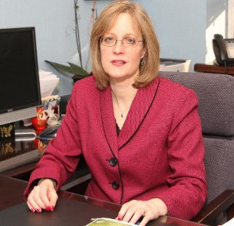
Kathleen Mooney – Port Washington Union Free School District
Dr. Kathleen Mooney has been employed by the Port Washington Union Free School District for 13 years, serving as director of Pupil Personnel Services for eight years and assistant superintendent for Human Resources and General Administration for four years. She later worked as interim superintendent of schools and was appointed superintendent in December 2012.
Over the past 28 years, Mooney has worked as an elementary classroom teacher, special education teacher and administrator. She holds a bachelor’s in elementary and special education from Molloy College, a master’s in special education from Adelphi University and a Certificate of Advanced Studies in Educational Administration from Hofstra University.
In 2007, Mooney received her doctorate in Education Administration from Hofstra University. For the last four years, she has continued at Hofstra, sharing her knowledge of Educational Leadership as an adjunct professor.

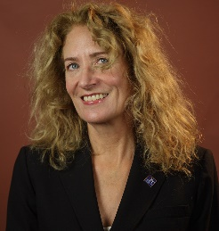
Kimberely Reiser – Nassau Community College
Kimberely Reiser is a professor at Nassau Community College (NCC) for 25 years, teaching General Biology, Microbiology and Parasitology.
Her record at both the local and state level speaks to Reiser’s commitment to shared governance. She was elected academic senator for 15 years until she became president of the statewide faculty governance organization, the SUNY Faculty Council of Community Colleges (FCCC) in June 2003. Leading 14,000 community college faculty for four years, she returned to the campus in 2007 as an elected departmental senator. She was elected chair of the Academic Senate from 2009-2013. Reiser currently serves as chair of the national Association of American University Professors (AAUP) Community College Committee.
Reiser has also served on numerous statewide task forces and boards, including the New York State Public Higher Education Conference Board; Cornell’s Institute for Community Colleges Advisory Board; statewide Assessment Reporting Task Force; Pandemic Flu Task Force; Faculty Development Task Force; Commission on Higher Education Advisory Council; Joint Committee on Transfer and Articulation; Transfer Review Committee; General Education Assessment Review Board and SUNY’s Shared Governance Transformation Team. In addition, she served on the executive board of the Empire State Association of Two-Year College Biologists (ESATYCB) for five years and was ESATYCB president before being elected president of the FCCC. She currently serves on SUNY’s Faculty Council of Community Colleges and the statewide Student Mobility Steering Committee.
She graduated from Drew University and earned her Ph.D. in Basic Medical Sciences from New York University at the School of Medicine.

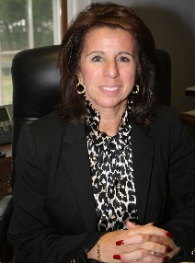
Maria Rianna – Glen Cove City School District
The Glen Cove City School District Board of Education unanimously appointed Maria Rianna as superintendent, beginning July 1, 2013. A veteran educator and administrator, Rianna had served as assistant/deputy superintendent since 2000.
Since 2011, Rianna has been the assistant superintendent for Instruction and Administration at the Smithtown Central School District, in charge of all aspects of the K-12 instructional program in a district comprised of 13 schools. She was responsible for creating and supervising the district budget, evaluating all curriculum administrators, implementing all professional development participating in labor negotiations.
Prior to Smithtown, she served as assistant superintendent and deputy superintendent in the Port Jefferson School District. The administrator also served as director of Special Education for the William Floyd School District, responsible for a $15 million special education budget and tasked with aligning the special education curriculum with New York State standards. She also served as both the assistant director for Special Education and coordinator for ELA, Reading, Preschool and Special Grants in the Patchogue-Medford School District, where she taught elementary special education.
Rianna completed her doctoral program at Hofstra University, where she also completed her business administrator’s certification. She earned her Professional Diploma from C.W. Post and received both her master’s and bachelor’s from Adelphi University.

