
Emerging Businesses

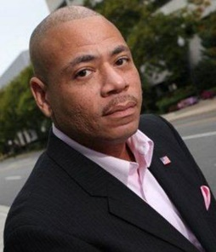
Lionel Chitty – Hicksville Chamber of Commerce, Moderator

Lionel Chitty has served as the Hicksville Chamber of Commerce president since September 2008. During his leadership, membership has grown more than 200 percent as a direct result of focusing on the changing needs of local businesses in a down economy. He has worked hard with his board of directors and members to add value to membership and make the Chamber of Commerce a resource for both residents and businesses alike.

In October 2009, Chitty was honored with the request to moderate the first debate between the candidates for the Nassau County Legislator (17th District) seat. He has represented small businesses through participation on boards and panels with organizations like the U. S. Small Business Administration, Vision Long Island, Dowling College/American Communities Institute and the Transit Oriented Development Workshop. Lionel is also the vice president of the Rotary Club of Hicksville South, a board member of 100 Black Men of Long Island Inc., board member of The Friends of The Adelphi Library and is chairman of the Hicksville Downtown Revitalization Committee. As Hicksville begins the task of revitalization of its downtown area, he spends a good portion of his Chamber related time working with elected officials, government offices, residents and local businesses to help bridge groups and unify the many voices of the community.

Chitty has spent 17 years in the mailing, shipping, warehousing and office automation arenas, holding positions in all facets of the industry including sales and managerial posts in operations, human resources and sales with leading organizations.

He is currently employed by Sir Speedy of Plainview as key account manager. He specializes in assisting his clientele with all of their print, copy and marketing needs. With a specific focus on the marketing aspect of services he provides, Chitty educates customers about marketing techniques that merge old practices with newer technologies. These include business objectives, data services, marketing activities and response mechanisms.
He graduated from SUNY Old Westbury.
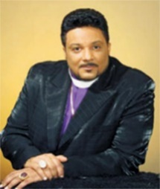
Bishop Harrison Hale – Bishop Harrison Hale Ministries
Born at Central Suffolk Hospital in Riverhead, Bishop Harrison Hale is the face of Harrison Hale Ministries.

After graduating from Riverhead High School in 1977, Hale joined the Church of God In Christ (COGIC). He spent years working as a deacon, van driver, Sunday School teacher, pastor aide leader, personal aide and YPWW president. He was licensed as a minister in 1981.

Hale served at COGIC until 1985, when he transferred his membership to Philadelphia COGIC. He took on the roles of Sunday School teacher, pastor aide president, president of the Ministers Board and secretary to the superintendent.

Hale was ordained back in New York in 1989, serving at the state level as a financial committee members, president of the Ministers Board and superintendent of the new Covenant District. He later served as superintendent of the cornerstone district, executive secretary and member of the executive board.
Hale accepted his pastoral calling in 1990, opening Cornerstone Church of God In Christ. During his 21 years as pastor, three churches have been built, 14 pastors have been installed across the world and manages two international orphanages with more than 450 children. He also oversees other pastors in New York, Costa Rica, Panama and Nicaragua.

Hale graduated from United Christian College of Sacred Theology in Queens, receiving his Doctor of Divinity in 1994 and Sacred Doctorate of Theology in 1995. He became a bishop in 2005. Hale is among 200 others on the Board of Bishops.

He founded the Harrison Hale Community Educational and Resource Center in Medford, as well as the Community Parish Hall/Café and Cornerstone Youth Church partnership with Stony Brook University in 2011. This led to a food pantry, after school programs, vocational schools and other programs. Hale also founded the Betty Hale Home of the Brave shelter for homeless veterans.

Over the years, Hale’s received a number of honors and awards. He received the Congressional Recognition Award, Gordon Heights Fire Department Chief Award and more than 70 proclamations from municipalities.
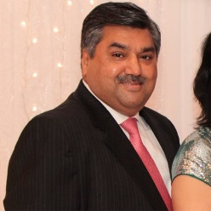
Kamlesh Mehta – South Asian Times
A founder of India Day Parade, Kamlesh Mehta hails from a prominent Indian family. He started his diamond-trading business in 1986, moving the company to New York in 1986. His business now includes Europe and Far East Asia.

Mehta delved into media in 2008, founding the South Asian Times, a weekly publication for South Asians across America.

The businessman was appointed as director of Nassau County Office of Business and Economic Development in 2010.

Mehta started the Rotary Club of Hicksville South in 2009, before serving as assistant district governor in 2012-2013 and chair of the Council of President for the 2013-2014 year. He’s also involved in numerous other community organizations, including the Rajasthan Association of North America.

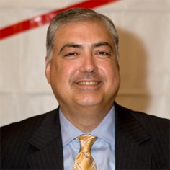
Jorge Martinez – Long Island Hispanic Chamber of Commerce
Jorge Martinez is president of BCM Solutions, a third-party administrator dedicated to helping organizations become more efficient and effective by outsourcing their business procedures. He also holds the position of compliance officer for American Transit Insurance Company.

A Freeport resident for more than 30 years, he was elected as a Village of Freeport Trustee. Martinez is the first Hispanic elected to this position.
He is the associate director for the Board of Directors of Bethpage Federal Credit Union, a former president of the Long Island Hispanic Chamber of Commerce and deputy chairman of the Village of Freeport Zoning Board. Additionally, Martinez has served as a coach in the Freeport PAL Sports League and Freeport Little League, as chairman of the Sanitation Board, commissioner of Human Relations Board for Village of Freeport, and as a member of the board of directors for the Girl Scouts of Nassau County.
As a result of his commitment to the community, Martinez has been the proud recipient of many awards, including: Molloy College St. Martin de Porres Award for Leadership, Unispan Award from Hofstra University, Hispanic Heritage Award from the Town of Hempstead and various community awards from Nassau County, Suffolk County and the Village of Freeport.

Born in Cuba, Martinez came to America in 1968 and settled on Long Island. He graduated from Hofstra University.
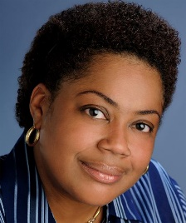
Yvette Richardson – Sabir Richardson & Weisberg Engineers
Yvette Richardson is a principal of Sabir Richardson & Weisberg (SRW) Engineers in NYC and has more than 20 years of experience in design, construction, facilities management, and financing in the public and private sectors.

Prior to SRW, she was an MEP project manager at Bovis Lend Lease on the World Trade Center Memorial and managed over $80 million dollars of construction, a vice President at Citibank Community Development and managed the engineering risk of Citibank’s community development lending portfolio for the Northeastern United States valued at over $400 million dollars and held various other positions at New York Presbyterian Hospital, Meyer Strong & Jones and electrical contracting companies.
She also volunteers with the Girls Scouts and NYC NAACP ACT-SO program.
Richardson is a licensed professional engineer with a degree from Rensselaer Polytechnic Institute.

