
Future of Energy on Long Island

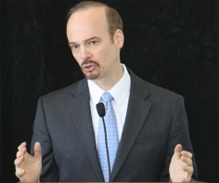
Neal Lewis – Sustainability Institute at Molloy College, Moderator
Neal Lewis is an environmental attorney with more than 25 years of experience with not-for-profit advocacy on Long Island. Lewis serves as the executive director of the Sustainability Institute at Molloy College and an adjunct faculty member at the college. The Sustainability Institute integrates concepts of sustainability into the academic life of Molloy College and serves as a resource on environmental stewardship to ensure a sustainable future. Top priorities for the institute include fighting to curb global warming, promoting clean energy, advancing safer alternatives to toxic pesticides, preserving open space and supporting smart growth.
Lewis and the Sustainability Institute maintain several on-going projects include: the Clean Energy Leadership Task Force, the Long Island Clean Energy Roundtable, and the Long Island Green Homes Consortium. The Sustainability Institute team also authors “Green Papers” which provide non-partisan issue analyses and policy recommendations. Two of the Institute’s green papers have been relied upon and cited in legislation that set stricter standards for home building codes (for 10 L.I. towns) and set standards for home energy audits (in Suffolk County).
He is also a volunteer member of the LIPA Board of Trustees for four years. During that time he’s advocated for more funding for efficiency programs including the Efficiency Long Island Program that is now funded at $120 million annually. He has also been an advocate for expanding LIPA’s solar programs including the first Feed-In-Tariff (clean solar initiative) in New York State approved by the trustees in September 2013 for 100 MW.
In addition to his role running the Sustainability Institute and serving as a founding member of the Vision Long Island Board of Directors and volunteering with LIPA, Lewis also serves on the Nassau County Planning Commission and the New York State Department of Environmental Conservation’s Advisory Committee on Open Space Preservation.

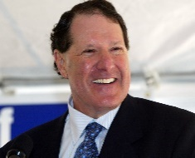
Ross Ain – Caithness Long Island
Ross D. Ain, president of Caithness Long Island, LLC and executive vice president of Caithness Energy, L.L.C., works on development and regulatory matters for Caithness. Under his direction, the Caithness Long Island II project, a 750 MW combined cycle power plant principally fueled by natural gas, has been selected by LIPA from among 45 project proposals to be the next baseload power plant constructed to serve Long Island. Ain also directed efforts to develop the Caithness Long Island Energy Center, a 350-megawatt combined cycle power plant that went into service in 2009 and currently supplies 10 percent of LIPA’s load and generates 20 percent of the power generated on Long Island. It is the most efficient, cleanest and most water conserving power plant serving Long Island’s needs, only to be surpassed when Caithness Long Island II comes on-line in 2018.
Ain has been active in the energy field for more than 35 years. He began his career as a legislative counsel to the House of Representatives and then counsel to the Energy and Commerce Committee of the House during the passage of major energy legislation in the 1970’s. He then worked at the Federal Energy Regulatory Commission directing programs establishing the independent power industry. From 1980-1994, he practiced law, advising developers of renewable, cogeneration and other power projects. In the 1980’s, Ain was a member of the board of directors and served as outside counsel of the company that developed the Solar Energy Generating System (SEGS) technology and SEGS I – IX projects, the longest running solar power generating projects in the United States.
Since 1994, he has been a senior executive with two private independent power companies which developed, owned and operated wind, solar, geothermal, hydro and natural gas fired generating plants throughout the United States. Ain joined Caithness in 1999. In addition to its Long Island projects, Caithness recently developed and constructed the Shepherds Flat Wind Farm, one of the world’s largest wind-energy facilities. Located in eastern Oregon, the Shepherds Flat Wind Farm began commercial operations in September 2012 and is comprised of three separate projects with a combined generation output of 845 MW.
Ain graduated from Columbia College and holds a law degree from Columbia University School of Law.

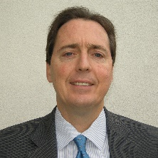
John J. Keating – National Grid
John Keating is a lead economic development specialist for National Grid. National Grid is an international electricity and gas company based in the UK and northeastern US. On Long Island, National Grid provides natural gas service through its extensive distribution system and manages the distribution of electricity on behalf of the Long Island Power Authority.
Keating’s background includes experience in power plant operations, development of energy efficiency programs, marketing and strategic planning. He received a bachelor’s in Electrical Engineering from New York Institute of Technology and an MBA in Finance from Dowling College. He is also a certified energy manager.

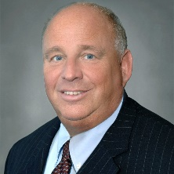
Richard Kessel
Richard M. Kessel, an expert in New York energy issues, served three years as president and CEO of the New York Power Authority (NYPA) from 2008-2011.
During Kessel’s term, NYPA made significant strides in life extension and modernization programs at its major upstate hydroelectric facilities. He worked closely with New York State and local economic development agencies, under the leadership of Governors Paterson and Cuomo, to optimize the available amounts of low-cost hydropower from NYPA’s large hydroelectric projects on the Niagara and St. Lawrence rivers to spur capital investments and jobs in Western and Northern New York. Kessel’s attention to economic development included NYPA’s transitioning to a new statewide power initiative – the Recharge New York Program – spearheaded by Governor Cuomo, for providing a new infusion of lower cost power for job retention and creation by businesses. He championed energy efficient and clean energy initiatives, with NYPA’S setting new records for each of the last two years – $175 million in 2010 alone – for its investments in there technologies. He also advanced proposals for the development of an offshore wind power project in the Great Lakes, and a statewide solar energy initiative, to add to the state’s clean energy supplies and encourage the development of job-producing alternative energy industries.
Prior to joining NPYA, Kessel served two terms as chairman of the Long Island Power Authority (LIPA) Board of Trustees. He began his career in public service as executive director of the New York State Consumer Protection Board, where he successfully negotiated rate freeze agreements with Consolidated Edison, Niagara Mohawk, and Orange and Rockland Utilities.
Kessel graduated from New York University and earned his master’s degree from Columbia University.

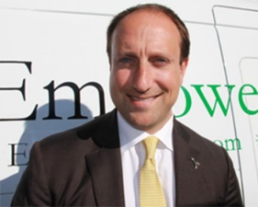
David Schieren – EmPower Solar
David Schieren leads EmPower as its CEO. He co-founded the company in 2003 with the goal of EmPowering people to use clean energy to control energy costs, clean the air, end oil dependency and dramatically improve the standard of living. Schieren is responsible for leading and managing the company, with a focus on business development, strategy, corporate finance, recruiting and corporate culture. He works closely with business partner and COO Greg Sachs on leading and growing the company.
As an advocate, Schieren conducts outreach to build support for clean energy amongst political, community, business and religious leaders, and the public at large. He has testified before the United States Congress Science Committee, about the Solar Decathlon, solar energy and hydrogen fuel, and has been involved with numerous TV, print, internet, radio and documentary interviews. Schieren is a North American Board of Certified Energy Practitioners (NABCEP) Photovoltaic Installer.
He graduated from the University of Vermont, where he received the Freeman Saltus Award in Economics, and earned a master’s in Energy Management from the New York Institute of Technology, where he received the Faculty Award for outstanding achievement. Schieren started his career as an Institutional Equity Advisor at Merrill Lynch where he sold Japanese equities to large U.S.-based investors. He co-founded the Solar Decathlon Alumni Association that is building an alumni community and advocacy group from the participants in the U.S. Department of Energy’s Solar Decathlon bi-annual competition. Schieren participates in several key organizations to help advance renewable energy in the region, including the Long Island Solar Energy Industry Association.

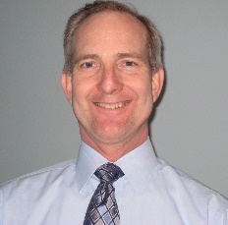
Michael Voltz – PSEG
Michael Voltz joined Lockheed Martin as Director of Energy Efficiency and Renewables for PSEG Long Island in October 2013. He previously was a director at LIPA and at Central Hudson Gas & Electric, where he worked for 30 years in power generation, customer services, energy efficiency and regulatory affairs.
Voltz holds a bachelor’s in Mechanical Engineering from Rensselaer Polytechnic Institute and a master’s in Business from Union College. He is a licensed professional engineer in New York State.

