
Luncheon

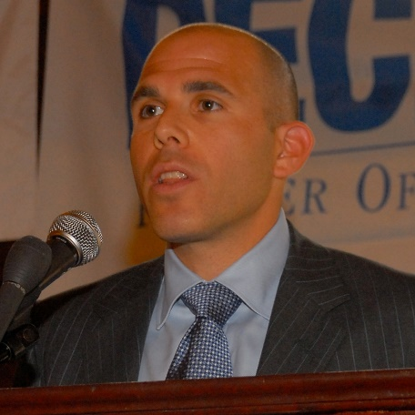
Scott Rechler – RXR Realty

Scott Rechler is the chief executive officer and chairman of RXR Realty LLC (RXR), a multi-billion dollar private real estate company which was formed subsequent to the sale of Reckson Associates Realty Corp (“Reckson”) to SL Green in January 2007, one of the largest public real estate management buyouts in REIT history.

Rechler served as CEO and chairman of the Board during Reckson’s dynamic growth throughout New York City, Long Island, New Jersey, Westchester and Connecticut. Rechler was the architect of Reckson’s $300 million IPO in 1995 and $6.5 billion sale in 2007 generating a 715 percent total return to Reckson shareholders.

Since its formation in January 2007, Rechler has led RXR in becoming one of the New York Tri-State area’s leading real estate companies, accumulating a portfolio with a gross value of approximately $8.0 billion comprised of 111 properties encompassing over 21.7 million square feet.

In June 2011, Rechler was appointed by New York Governor Andrew Cuomo to serve on the Board of Commissioners of the Port Authority of New York and New Jersey, and in September 2011, he was named to serve as vice chairman of that board. Rechler also serves as chairman of the Port Authority’s Capital Planning Committee, where he oversees the Port’s $30 billion capital budget including the World Trade Center redevelopment. In May 2013, Rechler was appointed to represent Governor Cuomo on the Board of The National September 11 Memorial & Museum at the World Trade Center Foundation, Inc.

Rechler is actively involved with the Real Estate Roundtable, for which he is a member of the Board of Directors and Co-Chair of its Political Action Committee.

Rechler prides himself on enhancing the communities where RXR operates. As such, he serves as a member of the Real Estate Board of New York, member of the Hofstra Honors College Advisory Committee, as well as the NYU Real Estate Institute Advisory Committee. In addition, Rechler serves as the co-president of the Board of Trustees for Friends Academy and serves on the Board of many of the region’s top cultural institutions such as the Tribeca Film Institute and the Long Island Children’s Museum where he serves as its co-chairman of the Board.

Rechler graduated from Clark University. He earned his master’s in Real Estate at the New York University Schack Institute.

Luncheon

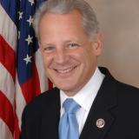
Steve Israel – House of Representatives

Sworn into Congress in 2001, Steve Israel represents New York's 3rd Congressional District, including the communities of Huntington, North Hempstead, Queens, Oyster Bay, and Smithtown.

Israel is the chairman of the Democratic Congressional Campaign Committee. In March 2012, he was appointed to the U.S. Holocaust Memorial Council. In March 2013, Israel was appointed to the U.S. Military Academy (USMA) Board of Visitors, providing the president recommendations on USMA matters.
Israel is considered a leader on energy security, reducing our national dependence on foreign oil, lowering energy costs and creating an innovative clean technology economy. His key energy accomplishments include funding the U.S.-Israel Energy Cooperation Act and the Advanced Research Projects Agency for Energy.

A passionate and relentless advocate for veterans and military families, Israel has secured more than $5 million in overdue benefits for Long Islanders who served their country. He has visited U.S. troops in conflict areas on nine occasions, including visiting highly-remote fire bases in Afghanistan.
Israel is a defender of consumers, authoring a bill that would take arsenic – a known carcinogen – out of the poultry supply and working to implement mandatory rules for medicine cups, which due to frequent flaws lead to over- or under-dosing children.

The congressman has also been an active voice in the Middle East, supporting assistance for the State of Israel and American-Israeli relations. He called for the arrest of Iranian President Ahmadinejad on charges of incitement and genocide, led bi-partisan efforts to strengthen sanctions against Iran, and helped lead the funding of cutting-edge military equipment and technologies to maintain Israel's qualitative military edge. In March 2012, he was appointed to the U.S. Holocaust Memorial Council.

Israel also considers himself a staunch advocate for middle class families. He’s repeatedly called for a revision of the tax code to reflect regional variations in cost-of-living and helped author the Tax Equity Act, legislation that would level the playing field for families living in high cost-of-living communities. He has long sought a permanent fix to the Alternative Minimum Tax. In the 111th Congress, the congressman voted to extend the payroll tax cut for working families, saving the average middle class family $1,500 in 2012. He also called for an extension of pre-tax commuter benefits in December 2011, a critical benefit for New York commuters.

Among Israel's local accomplishments are securing record-level federal investments to protect the Long Island Sound; seeking to protect Long Island taxpayers by changing the federal tax code to reflect the local cost-of-living; and supporting local women's health initiatives – a priority in his role as co-chair of the House Cancer Caucus.

