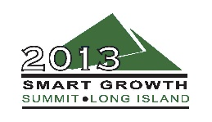
New Town Centers

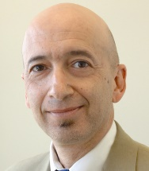
David Winzelberg – Long Island Business News, Moderator
David Winzelberg is an award-winning reporter for Long Island Business News, writing exclusive stories about real estate, development, and land use issues. Before coming to LIBN, Winzelberg spent 20 years writing about Long Island for The New York Times. His work has appeared in several other publications including Forbes and The Atlantic, and he’s also been featured on CNBC’s “American Greed,” and WLIW’s “Q&A” and “21 Forum.” Winzelberg is a frequent moderator and panelist at prominent industry events on Long Island.

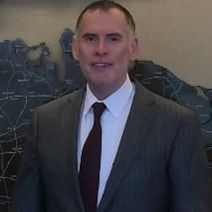
Thomas C. Graham – RXR
Since January 2013, Thomas Graham has served as the vice president and project executive for RXR’s sustainable, smart growth initiative at Garvies Point in Glen Cove. Responsibilities include working together with the Public-Private Partners, the City of Glen Cove IDA/CDA, to perfect the environmental cleanup and approvals, continue product development, commence construction and bring the community to market in 2014.
Before that, he worked as chief project executive for K Hovnanian’s 77 Hudson Hi-Rise in Jersey City from 2005-2012. He teamed up with community and municipal officials to garner approvals in record time. The building was completed on schedule, under GMP budget, and as a JD Powers award winning community.
Graham also previously worked as vice president of Land Development for K. Hovnanian Companies from 1996-2005, senior vice president of Operations Hills Development Company/Gale Wentworth & Dillon from 1993-1995, project manager with DKM Properties from 1990-1993 and residential projects director for Lanid Corporation from 1978-1990.

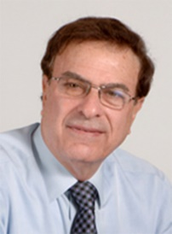
Donald Monti – Renaissance Downtowns
Donald Monti, president and CEO of Renaissance Downtowns, has more than 35 years of diverse experience covering all aspects of the real estate spectrum having played a major role in the development, construction and management of 80+ development projects. The company is master developer in numerous projects throughout the Northeast, with a total development value in excess of $7 billion.
Their $2 Billion Hempstead TOD represents a true game changer for Long Island and other mature suburbs by ushering in the ideals of large scale, mixed use, smart growth redevelopment that abide by Renaissance’s “Triple Bottom Line” approach to real estate development – social, environmental and economic responsibility. The Hempstead effort received its final approvals in July, 2012, setting the stage for construction in 2013, and was featured as a case study in responsible suburban downtown development at the 2012 United Nations World Energy Forum in Dubai last October, where the CEO was a keynote speaker. Under Monti’s leadership, the company has instituted the nation’s first grass roots, social media campaign for public outreach (“Crowdsourced Placemaking”), a patent pending methodology which allows community members to provide input throughout the planning and development process. Renaissance has also been instrumental in the creation of some of the nation’s most innovative zoning codes, which marry the concepts of green building design, sustainability and locally-based economic development.
Monti has been quoted in numerous nationally respected media sources as an expert in downtown revitalization and been a keynote speaker / panelist at numerous national conferences, including the CNU annual congress, Railvolution, American Planning Association, California Downtown Association, Wharton Real Estate Summit at the NYSE, Private Equity Real Estate Annual Forum, and Vision Long Island amongst others. He has also been heavily involved in community affairs, including serving on the board of directors for the Don Monti Memorial Foundation and being honored as Man of the Year by the American Red Cross.

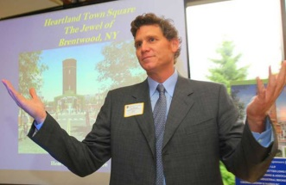
David Wolkoff – Heartland Town Square
David Wolkoff is a principal at Heartland Business Center, a privately-owned real estate company in the Tri-State Area. He oversees the acquisition, financing, management and development of major real estate projects. Currently, he is focused on the development of Heartland Town Square, a 450-acre “Smart Growth” town in Suffolk County, as well as a 1.3 million square foot building in Long Island City.
Before Heartland, from 1989-1993, Wolkoff worked in the lending and workout groups of Chemical Bank’s corporate real estate division. He was responsible for the management of specific customer relationships and projects, as well as, analyzing faltering and failed loans.
Wolkoff is a member of the Board of Directors of F.E.G.S one of the largest and most diversified voluntary, not-for-profit health, education and human service organizations in America. He is also involved in many other charitable organizations, although he’s especially fond of the Food Allergy Initiative (FAI) due to his son life-threatening allergies to nuts and peanuts.
Wolkoff is a graduate of Harvard University and received his MBA from Columbia Business School.

