
Post-Sandy: Disaster Planning and Recovery
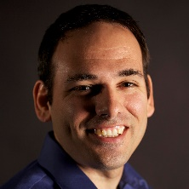
Carl Corry – Newsday, Moderator
Carl Corry is the online local news editor at Newsday, where he leads a community news team that participated in Newsday’s breaking news coverage of Superstorm Sandy, the blizzard of 2013 and Tropical Storm Irene.
Corry, a director at-large of the Society of Professional Journalists, is a frequent speaker on smartphone journalism. He previously was executive producer of News 12 Interactive and served as editor of Long Island Business News.

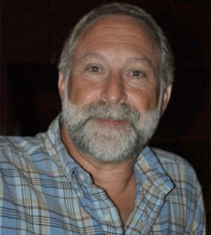
Ron Benenati – FEMA
Ron Benenati spent 15 years as proprietor of Media Liaision, a boutique Public Relations company providing services to nonprofits across a broad range of social issues including: the New York Open Center, Design Spirit Magazine, CERES, Social Investment Forum and Vassar College. Another 8 years more recently spent networking, organizing and coordinating programs for agencies addressing the needs of frail elderly on a New York City-wide basis. This included coordinating the home delivered meals program for the West Side of Manhattan at Encore Community Services. He returned to his earlier roots addressing sustainability as associate editor of “SustainableBusiness.com,” until Sandy hit.
Following the storm, Benenati took a position in Community Relations with FEMA and met with Long Beach Residents, door-by-door, until April. FEMA then assigned him to the position of voluntary agency liaison, where he works with voluntary agencies, from national to local grassroots, to create a network capable of supporting the long term recovery of communities impacted by Sandy.

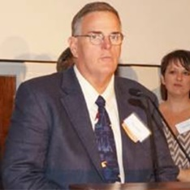
Rich Cantwell – Friends of Freeport
Rich Cantwell is a life-long Freeporter with deep ties to the community. A graduate of Freeport High School class of '76, Rich Cantwell and his family moved to Freeport in 1958 and opened Freeport’s first Carvel Ice Cream Store in 1966. In 1990, the first Carvel “mall-store” opened at Elk’s Plaza and Cantwell quickly became known as the mayor of the mall.
A long time fireman and boater, he serves as an associate member of Freeport’s Hose Company No. 3 and a Coast Guard Auxiliarist. He joined the Auxiliary in 1977, volunteering and teaching safe boating in Freeport for many years, becoming a licensed captain in 1985. His deep devotion to the fire service started when he rode his bicycle to the firehouse on Church Street as an Explorer, later joining the famed Engine Company, and moving to Hose 3 with his young family.
Cantwell works full-time as a fire dispatcher, in addition to serving as a founding member and president of the Friends of Freeport. Friends of Freeport is an organization of volunteers helping demolish, rebuild and repair neighbors’ homes damaged by Superstorm Sandy.

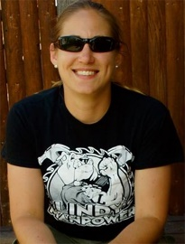
Amy Castiglia – Lindy Manpower
Amy Castiglia, 31, of Lindenhurst, began volunteering in her community a few days after Superstorm Sandy. She collaborated with other volunteers at Camp Bulldog, Lindenhurst's hurricane relief site, to garner donations and distribute needed supplies to victims in Lindenhurst. In November 2012, she took over the local volunteer effort, Lindy Manpower, organizing crews to complete the mucking, gutting and demolition homeowners needed. Lindy Manpower has also been able to provide building supplies to many homeowners due to grant funding and donations.
Castiglia is a member of Friends of LI and sits on the committee for the Village of Lindenhurst’s New York Rising Community Reconstruction Program.
She graduated SUNY New Paltz and the SUNY Farmingdale Nursing Program. Castiglia currently works as a critical care nurse in the Surgical Intensive Care Unit at Brookhaven Memorial Hospital Medical Center.
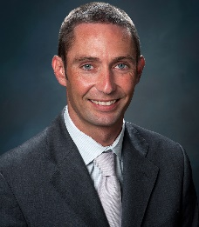
John H. McNally – Long Beach Activist
John McNally is the associate director for Regional Action for The Energeia Partnership at Molloy College. In this capacity, he is charged with working with The Partnership’s 250+ members to build consensus around and implementation of solutions to many of Long Island’s inextricable issues. McNally also designs opportunities for Energeia Partners to further their knowledge of the issues facing Long Island, to meaningfully engage in their communities and connect with others working on issues of importance.
Prior to his time at Energeia, McNally spent more than a decade working at the Rauch Foundation, most recently as its environmental program officer and communications director. As Program Officer, he oversaw the development and implementation of more than $8 million in grants to Long Island-based organizations. As communications director, he was responsible for both conceptualizing and implementing the Foundation’s communication strategies and served as the lead spokesperson for much of the Foundation’s work.
McNally also worked as a consultant with the Central Pine Barrens Joint Planning and Policy Commission in their effort to update the Land Use Plan that governs the uses of this critically important 100,000-acre region. He serves on numerous environmentally-related boards and committees, and frequently lectures on the challenges facing the Long Island region – both environmental and more generally as documented by the Long Island Index. He is a graduating member of the Energeia Partnership Class of 2007 and was recognized as a ’40 Under 40’ by Long Island Business News in 2011.
McNally is a 12-year resident of Long Beach, where he currently resides with his wife. He is deeply involved in many aspects of the Long Beach community, runs several Long Beach-focused on-line forums with several thousand ‘fans’ and has played a leadership role in many community organizing initiatives in response to Superstorm Sandy. He current serves as co-chair of Long Beach’s Community Reconstruction Program, a program administered by New York State to help increase resiliency and economic development in communities hardest hit by Sandy.
McNally graduated from Quinnipiac University and is currently enrolled in Vermont Law School, where he is pursuing a master’s in Environmental Law and Policy.

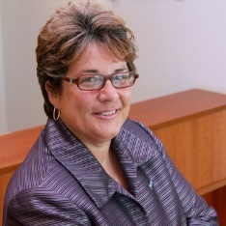
Theresa A. Regnante – United Way of Long Island
Theresa A. Regnante, president and CEO of United Way of Long Island, will tell you that helping people is in her DNA. Growing up in a fundraising family, Regnante went with her father to various places to sell raffle tickets for St. Francis Hospital. Today, she has been a beacon of inspiration as she leads United Way of Long Island and supports its 125 community partners in the development of strategic initiatives that have a measurable and lasting impact on education, income stability and health throughout Nassau and Suffolk.
During her four years at the helm, Regnante has had an eye not only for growing the nonprofit organization, but for also seeking out opportunities that empower Long Islanders in need. Under her leadership, the organization has adopted a new approach to community problem-solving. This includes the procurement of $1.5 million in government, corporate and private grants to establish a workforce training center for the unemployed and underemployed.
She is currently co-chairing the Long Island Hurricane Sandy Unmet Needs Roundtable, a bi-county fund established to fill the gaps between the needs of disaster victims and available government resources. Regnante is leading a team that, as of June 2013, had raised in excess of $3 million to assist Long Islanders in the rebuilding of their homes, neighborhoods and livelihoods. She is a firm believer that good leaders are only as good as those with whom they surround themselves.
Regnante has been widely honored and recognized regionally for her accomplishments. She received the honorary degree of Doctor of Laws from St. Joseph’s College in New York in 2012. She was also the recipient of a 2013 “Outstanding CEO Award” from Long Island Business, Nonprofit Leadership Alliance’s 2012 Alumna of the Year and was recognized by Suffolk County Coalition Against Domestic Violence as the 2012 Woman Achiever of the Year. She is a member of the Long Island Index advisory committee, Adelphi University’s Institute for Social Research & Community Engagement, Vital Signs advisory board and Hofstra University’s Master of Public Health Program advisory committee. She also serves on the boards of the Advancement of Commerce, Industry and Technology and LISTnet.

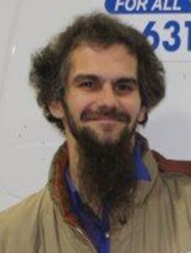
Jon Siebert – Friends of Long Island
Jon Siebert, 34, of Mastic Beach, has been assisting with Superstorm Sandy relief and recovery since the day after the storm. He served on the Executive Board of the Tri-Hamlet Hurricane Relief Committee, is a member of LIVOAD, founded Mastic-Shirley COAD, and co-founded Friends of Shirley and The Mastics and Friends of Long Island. Recently, he is a committee member on Mastic Beach's CRP committee, consults for Vision Long Island for Suffolk County's CRP outreach, and works with Project Hope as a crisis counselor in Riverhead and Brookhaven Townships.
Before Superstorm Sandy, Siebert consulted for and managed several successful businesses in various industries.

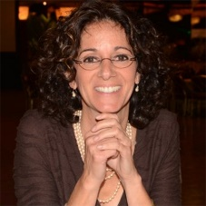
Randi Shubin Dresner – Island Harvest
Randi Shubin Dresner continues to serve as president and chief executive officer of Island Harvest Food Bank since 2001, working as a tireless advocate on behalf of people in need. Her work has raised awareness of people with disabilities and the insidious, yet often unrecognized problem of chronic hunger on Long Island.
Prior to joining Island Harvest, Dresner made her mark on several national and local organizations including the Heckscher Museum of Art, March of Dimes Birth Defects Foundation, The National Center for Disability Services and the National Multiple Sclerosis Society.
Utilizing her nonprofit management skills, she propelled Island Harvest’s unprecedented growth in its collection and distribution of donated food by more than 350 percent in the past 12 years. They now distribute more than 11 million meals to Long Islanders in need. Under her leadership, Island Harvest is among the region’s lead agencies in disaster-relief food and product distribution and support, as evidenced by the organization’s rapid response to Superstorm Sandy.

Dresner’s grasp of hunger and related issues has made her the go-to source for the press and government leaders, and as a result, serves on many state and local councils, including U.S. Senator Kirsten Gillibrand’s NYS Agriculture Working Group and the Suffolk County Food Policy Council. She was appointed by Governor Andrew Cuomo to serve on the Farmingdale State College Council, has been awarded an honorary doctorate of law degree from St Joseph’s College and is a member of the Energeia Partnership at Molloy College.
Twice recognized as one of Long Island’s Top-50 Most Influential Women in Business by Long Island Business News and recipient of the 2013 New York State Woman of Distinction Award, Dresner retired after more than 22 years as an adjunct faculty member at Molloy College and LIU CW Post in the Non-Profit Management/Fundraising Certificate Programs.

Kim Skillen – Neighbors Supporting Neighbors Babylon
Kim Skillen is the executive director and co-founder of Neighbors Supporting Neighbors Babylon (NSN), a volunteer nonprofit founded in the days after Superstorm Sandy. Skillen and her organization have focused on direct relief and restoration in the wake of this disaster. In the spring of 2013 NSN was designated as a FEMA VOAD (volunteer organization active in disaster).
Skillen is also a NY Rising CRP (Community Reconstruction Program) committee member for the Babylon/West Babylon Committee. This committee was one of four down state highlighted communities in Governor Coumo’s NY Rising Conference this fall.
Skillen is the district administrator for Secondary Curriculum and Instruction for Deer Park Schools. She lives in West Babylon with her daughter.

