
Rebuilding and Resilience
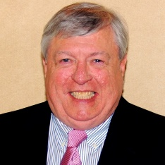
John O’Connell – Richner Communications, Moderator
John O’Connell is the executive editor of Richner Communications’ Herald Community Newspapers, an award-winning chain of 16 weeklies covering the South Shore of Nassau County. O’Connell has been the editorial department’s leader for 10 years, and previously served as Valley Stream Herald editor for five years, and reporter and managing editor with the Gold Coast Gazette in Glen Cove for five years prior to joining the Heralds. He is the immediate past three-term president of the Press Club of Long Island, the local chapter of the national Society of Professional Journalists.
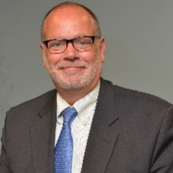
Ronald A. Beattie – Oakdale Chamber of Commerce
Ronald A. Beattie is the current president of the Oakdale Chamber of Commerce.
Beattie, an executive with experience in the computer-aided facilities management and technologies for commercial real estate worldwide, is president/owner of PlanZ Technologies in Oakdale. His firm provides consulting services in technology for commercial real estate clients.
A U.S. Coast Guard veteran with a B.S. in Business Management from the City University of New York/Staten Island, Beattie is former vice president and director of administration for Smith Barney Shearson’s Branch Real Estate Department. He also served as facilities-management systems manager for Citibank’s North American Banking Group, director of production and systems for architecture-design firm Mancini Duffy and as executive vice president/owner of PlanData Systems Corp. in Huntington, a consulting firm in real-estate facilities management and space documentation with clients on four continents.
Beattie is an active leader in the Long Island business community and speaks widely on CAD/CAFM and technology for commercial real estate. A member of the Suffolk County Vanderbilt Museum Board of Trustees since 2009, he was elected president of the board in 2012.

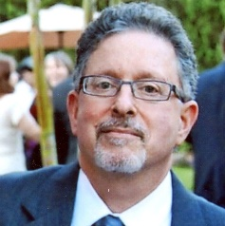
David Berg – Cameron Engineering & Associates
David Berg, AICP, LEED AP, is an associate at Cameron Engineering & Associates, where he has provided land use planning and environmental analysis for municipal and private clients for more than 15 years.
As the project manager of NYSERDA’s Climate Smart Communities for Long Island, Berg is assisting municipalities lower their greenhouse gas emissions, adapt to climate change and mitigate the effects of sea level rise. This will make Long Island communities more energy efficient and sustainable, while reducing the risks associated with more frequent and severe storms.
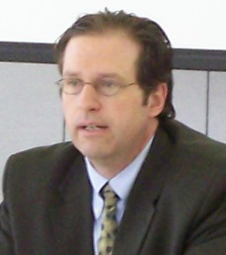
Berg is one of the project managers for the NY Rising Community Reconstruction Program, assisting one of Suffolk County’s Sandy-impacted areas develop a rebuilding and revitalization plan. He has been a board member of Vision Long Island, a smart growth advocacy organization, for many years.
Paul Beyer – NYS Department of State
Paul Beyer is the state director of Smart Growth Planning at the NYS Department of State. Beyer promotes the principles of Smart Growth on the state, regional and local level in New York. He also serves as a Department of State planner for several of Governor Cuomo’s New York Rising Community Reconstruction Program communities on Long Island.
His experience in land use and Smart Growth began when he worked in the New York State Legislature, where he focused on land use, environmental and public health policy. He served on the Planning Board in the Town of Amherst for five years, helping to develop the town’s Comprehensive Plan. Beyer also served on the Board of Directors of Partners for a Livable Western New York.
Beyer received his law degree from the University at Buffalo.

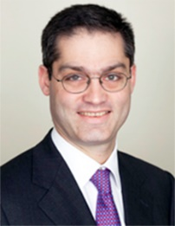
Jamie Rubin – NY Rising Storm Recovery
Jamie Rubin is the director of the state’s NY Rising Storm Recovery.

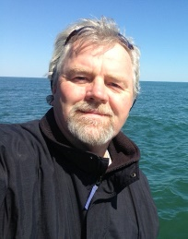
Until August 2013, Rubin was the New York Director of the president’s Hurricane Sandy Recovery and Rebuilding Task Force and a senior advisor to HUD Secretary Shaun Donovan. He was previously a non-resident senior fellow with the Brookings Institution Metropolitan Policy Program, working to identify and implement economic development strategies.
Until May 2012, he was a senior partner with BC Partners, a global private equity fund managing over $17 billion. He joined BCP in May 2008 to establish the firm’s first US office and subsequently built a team and directed over $1 billion of direct investment in the US by BCP. Before BCP Rubin was a partner with One Equity Partners, JP Morgan’s private equity fund, where he was one of the founding partners in 2001.
He is chairman of the board for Common Ground Communities, the country’s largest developer and manager of supportive housing for the formerly homeless. In 2008, Rubin co-founded Greater New York prevent the economic crisis from destroying New York’s most promising community organizations.
Jamie is active in Democratic politics and was one of the senior members of the Obama Transition Team in 2008. He holds a law degree from Yale University and a degree from Harvard University.

Rob Weltner – Operation SPLASH
As a child growing up in south Freeport, Rob Weltner spent most of his days crabbing, fishing and boating on the back bays of the South Shore. He got his SCUBA certification in 1981 and later helped start the Freeport Fire Department Underwater Search and Rescue Squad. Growing aware the sea life was in trouble, Weltner started Bring Back the Bay, working side-by-side with Operation SPLASH – a nonprofit that cleans up garbage in bays and estuaries. By 2000, he was elected the board president of Operation SPLASH.

He retired from a career as an electrician in 2005 and focused on tending the bays. Since taking office, SPLASH membership increased from 150 to 3500. And with the help of an extraordinary group of SPLASH officers and members, the organization has expanded their number of chapters and boats. They’ve removed more than a million pounds of trash from the South Shore Estuary Reserve and helped initiate projects like redirecting the Jones Beach Sewage Plant discharge pipe. Weltner secured funding, designed and installed a debris trap at Mill Basin in Freeport that’s prevented more than 1,000 barrels of garbage from entering the estuaries and won SPLASH the 2006 South Shore Estuary Reserve Stewardship Award.

Weltner is still a member of fire department’s Underwater Search and Rescue Squad. He’s also a member of the South Shore Bayhouse Owners Association, commissioner for the Conservation of the Environment for Freeport, on the Nassau County Soil and Water Conservation District Board of Directors, Nassau County’s representative for the New York State Open Space Conservation Plan, a member of the Nassau County Hundred Million Dollar Environmental Bond Act Review Committee, an active member of the Western Bays Work Group and a voting member of the Citizens Advisory Committee for the South Shore Estuary Reserve.
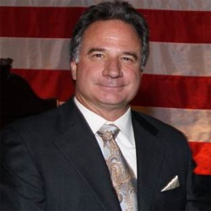
Andrew Zucaro – Zucaro Construction
In 1979, Andrew Zucaro started his own construction business. Zucaro Construction grew into an established general contractor for commercial construction on Long Island. Now in its 33rd year, Zucaro Construction has expanded to add Zucaro House Lifters. Approved by NY Rising, the company is doing structural elevation and foundation repair for recovery efforts connected with Superstorm Sandy.
Zucaro Construction was involved in the first LEED-certified hotel on Long Island, the Viana Hotel; full renovation of The Space at Westbury; Parker Waichman, Bentley-Lamborghini of Long Island, King O’Rourke Cadillac, Buick GMAC, Four Points Sheraton, Millers Ale House and Garden City Country Club.
Zucaro sits on the board of Nassau University Medical Center, USGBC of Long Island and Hope House Ministries. He was named the Italian Board of Guardian’s 2009 Humanitarian of the Year, 2011 Man of the Year for Eden II/Genesis Foundation and Businessman of the Year by Nassau Republican Committee.
Andy is a proud supporter of many charities, especially focusing on charities for children with Autism and various support programs for children.

