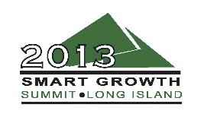
Smart Growth and New Urbanism 101
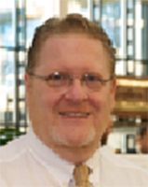
Alexander D Latham III – ADL III Architecture, Moderator
Alex Latham is owner and principal of ADL III Architecture, located in Northport, and one of the founding board members of Vision Long Island. ADL III Architecture is a multifaceted architecture and planning firm with focuses in architecture and town planning.
ADL III’s work includes significant water front residential projects on Long Island, throughout the United States and Canada, and numerous Main Street mixed use projects.
Town Planning work includes corridor revitalization projects in Mastic/Shirley, Middle Island/Coram, and Ronkonkoma. ADL III has produced some of the first true design guidelines on Long Island for the town of Brookhaven for Ronkonkoma and Portion Road, and for County Route 39 for the Town of Southampton.
Other Smart Growth projects include land use studies, visioning and design work in Huntington, Huntington Station, Wyandanch, New Cassel, Roosevelt, Yaphank, Rocky Point, Shoreham, Peekskill, Newburgh, and New Orleans.

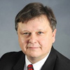
William Tuyn – Greenman-Pedersen

With more than 28 years of experience in the design and management of land development projects across a diverse range of places and forms, William Tuyn is a well-respected expert in the industry, serving on the Executive Board of the National Association of Home Builders, the Boards of the New York State Builders Association and Research and Education Foundation, Partners for a Livable Western New York, and the Buffalo Niagara Builders Association. An active member of the Congress for the New Urbanism, he is co-chair of the steering committee of the Buffalo Niagara Consortium for the New Urbanism, a group that presented Buffalo Niagara to CNU as the site for their annual international Congress and who were successfully awarded CNU22 in 2014. An avid advocate Smart Growth and sustainable design, he also serves on the Board of Advisors for Sansur Renewable Energy, Inc., an international wind and solar energy development company based in Tampa Florida. He also serves on the board Vision Long Island.

Currently, Tuyn is involved with the master planning and design of several TOD and TND projects from New York to Florida.

He is also a member of the Urban Design Working Group for the City of Buffalo Green Code and the Village of Williamsville Traffic and Safety Committee, and Zoning Board of Appeals.

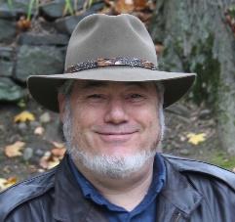
Padriac Steinschneider – Gotham Design

Padriac (Paddy) Steinschneider is a placemaker. Coming from a background of environmental science, he is all about creating buildings and places that make sense for where they are. He is a designer, planner, builder, advocate and whatever else it takes to create a good place. He is committed to the wholeness of place, which includes the people who live there and their history, as well as the natural environment and the existing infrastructure.

Steinschneider is the president of Gotham Design & Community Development Ltd. Since founding Gotham in 1978, he has enjoyed operating his firm as a loose association with others committed to creating good places. Although not a licensed architect himself, Steinschneider continues to associate with designers, architects, planners, engineers, developers, investors and end users to create special places. He is also a developer and provides construction management services on special projects that would be simply too difficult to get built any other way.

He is all about creating useful, beautiful buildings and places that fit their purpose and context. Steinschneider has been accused of being a traditionalist, despite designing some edgy buildings, and of not being a traditionalist, despite restoring several historic buildings and neighborhoods. For him, it is about what fits best.
Steinschneider is involved in associated activities on both the local and regional scale. Based in Dobbs Ferry New York, he has been a member of numerous committees for the Village and School District. He helped create the Ferry Festa, an annual event that brings fun and focus to the downtown. He touts it as early Tactical Urbanism. He also participated on the Mid-Hudson Region Sustainability Planning Committee, focusing on land use, transportation, and livability.
Steinschneider is also a founding member of the New York Chapter of the Congress for the New Urbanism, serving as chief operations officer. In this role, Paddy has direct access to and has helped shape the cutting edge ideas that are transforming our Nation into a more sustainable place. His favorite hat is his New Urbanism cap, which has a logo on the back that says, "Shaping the world one town at a time."

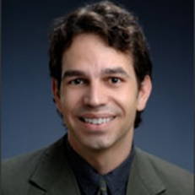
Marc Wouters – Congress for the New Urbanism New York
With more than 20 years in architectural design and urban design, Marc Wouters is the chairman for the Congress of New Urbanism New York State chapter.
A licensed architect and LEED-accredited, Wouters served as a partner at the prestigious firms of Cooper Roberston & Partners and Torti Gallas and Partners. In both, he led designs for new communities, urban infill projects, new town centers and various architectural projects. As a project architect for Hartman-Cox Architects, Wouters created architectural designs for several renowned institutions including the Smithsonian Institution and the John F. Kenney Center for the Performing Arts.
Wouters currently volunteers time with CNU and the US Green Building Council LEED ND Neighborhood Development program. He has both a bachelor’s and a master’s in Architecture from the University of Virginia, and was a Visiting Scholar at the American Academy in Rome.

