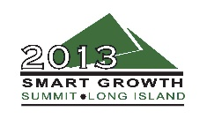
Sustainability, Planning and Implementation
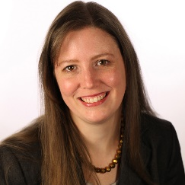
Elissa Kyle – Vision Long Island, Moderator
A Huntington native, Elissa Kyle graduated Carnegie Mellon University with a Bachelor of Architecture in 1999. Prior to joining Vision Long Island as director of Sustainability, she participated in numerous community charrettes throughout Long Island as a member of Vision’s design team with ADL III Architecture.
In addition to her work with both Vision Long Island and ADL III Architecture, Ward-Kyle is also a member of the Huntington Historic Preservation Commission. Growing up just a short walk from Huntington village, she grew to appreciate the benefits of living in a traditional, walkable community-especially in the years before learning to drive. Understanding that much of Long Island doesn’t have these qualities, she hopes to help other Long Island communities that wish to have thriving downtowns, develop them.

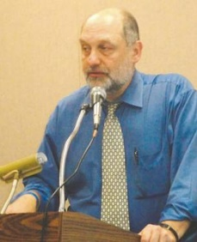
Gerry Bogacz – New York Metropolitan Transportation Council
Gerry Bogacz has been the planning director for the New York Metropolitan Transportation Council (NYMTC) since 1997. NYMTC is a regional council of governments which is the metropolitan planning organization for New York City, Long Island and the lower Hudson Valley. NYMTC is responsible for planning for the use of federal transportation funding in its planning area.
Prior to his work at NYMTC, Gerry spent 10 years as the director of Planning for the Westchester County Department of Transportation. He holds a master's degree in Urban Planning from NYU and a master's degree in Public Affairs from Fordham University.

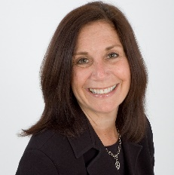
Frances B. Reid – Town of North Hempstead
Since joining the Town of North Hempstead as the chief sustainability officer, Frances Reid has had the honor of overseeing two award winning programs. The NYS Environmental Excellence award-winning Town of North Hempstead Recycling Partnership Program, serving nine school districts, 49 buildings and 40,000 students, teaches an invaluable life lesson to our youth who will eventually become the stewards of our community and our precious environment while saving money for taxpayers.
Reid has also been able to launch The First Pharmaceutical Collection Event in Nassau County and the recipient of the 2011 US EPA Environmental Quality Award and the first Residential & School Composting & Rain Barrel Programs on Long Island.
The Office of Sustainability has been responsible for two major initiatives through grants from NYSERDA. The LI Green Homes consortium home energy savings program as well as serving as the lead agency for the 2013 Cleaner Greener Communities regional sustainability plan for all of Long Island.
Reid was born and raised in Brooklyn and has been a North Hempstead resident for 30 years.

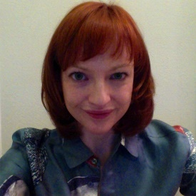
Lindsay Robbins – NYSERDA
Lindsay Robbins works in NYSERDA's New York City office, where she manages the public benefit corporation’s NYC multifamily team and works on the development and implementation of green building and energy efficiency programs for multifamily residential buildings. She also managed Phase I of NYSERDA's Cleaner Greener Communities Program, which funded the development of regional sustainability plans for New York State.
Before coming to NYSERDA, Robbins worked at New York University's Office of Strategic Assessment, Planning & Design where she worked on the development of NYU's Design Standards & Guidelines and NYU's 25-year real estate expansion plan.


Representative – Federal Transit Administration

