
Transit Opportunities
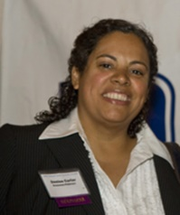
Denise Carter – Greenman-Pedersen, Moderator
Denise Carter is senior vice president and branch manager of Greenman-Pedersen’s Babylon office. A professional engineer with more than 25 years of experience, Carter manages a 160-person staff specializing in transportation planning, design and construction and program management projects throughout Long Island and the NYC metro area for state, municipal and transit agencies. Some of the projects she’s been involved in include NYSDOT Accelerated Bridge (Design-Build) Program, Route 347 Design, NSP/110 Interchange Design, Route 110 BRT Study, Town of Brookhaven Evacuation Study, East River Bridges Rehabilitation Program, Bayonne Bridge Navigational Clearance, LIRR Parking Expansion Design and Construction, Suffolk County Closed Loop Signal System Design and various Transit Signal Priority (TSP) Studies.
Carter holds a bachelor’s in Civil Engineering and is a licensed professional engineer in NY, NJ and CT. She is past president of the Long Island Branch of the American Society of Civil Engineers and has served as a board member for the American Council of Engineering Companies.

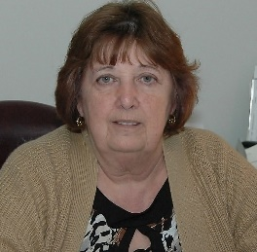
Patricia Bowden – Transit Workers Union Local 252
Patricia Bowden began her career with Suffolk Transportation Service in 1980 as a school bus driver in Bay Shore. In 1990 she was appointed assistant shop steward for Local 252 of the Transport Workers Union, holding that position until she was elected shop steward three years later. In 1999, she was elected vice president and began her job by overseeing the membership at Suffolk Transportation Service, which included the mechanics, bus fuelers, transit bus drivers, ADA bus drivers and all school bus drivers. Bowden addressed the daily needs of the membership while maintaining good will with the company. Additionally, she obtained her 19A Examiner’s License and served as a driver-trainer. She saw the membership at Suffolk Transportation grow over the years from 300 to over 1,800 at present.
In 2005, Bowden was elected president of Transport Workers Union Local 252 and continues to serve a membership of approximately 3,500 including Veolia Transportation, Suffolk Transportation Service, Courtesy/Atlantic Express and First Student. From the time she took over as president, Bowden has negotiated dozens of contracts. She is steadfast in her dedication to the membership of Local 252 and fights tirelessly for their rights.
Bowden is also a board member of the Living Wage Committee in Nassau County, and serves on the Transport Workers Union International Board as well as a member of the Executive Board of the Long Island Federation of Labor.
Having been residents of East Islip for most their lives, Patricia and her husband Stephan have seven children between them and enjoy fifteen grandchildren. While her children were growing up, Patricia Bowden volunteered her time as a Girl Scout Leader and a soccer coach.

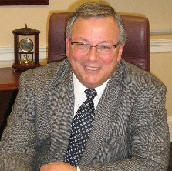
John R. Durso – LI Federation of Labor

Since 1999, John R. Durso has served as the president of Local 338, RWDSU/UFCW which represents more than 19,000 men and women working in New Jersey, New York City, Long Island, Westchester, Putnam and Hudson counties. Local 338’s members include: supermarket and drug store employees, health care workers, pharmacists, delivery workers, dairy workers, and employees at warehouses and numerous other retail food services.

Durso is also the president of the Long Island Federation of Labor, AFL-CIO, the fourth largest central labor council in the United States, representing 250,000 union members in Nassau and Suffolk Counties.

Durso serves as an international vice president of the United Food and Commercial Workers (UFCW), vice president of the Retail, Wholesale and Department Store Union (RWDSU), an affiliate of the UFCW, and a vice president of the New York City Central Labor Council. In addition, John holds positions on the Towns of Hempstead and Oyster Bay Labor Commissions, and the Town of Hempstead Workforce Investment Board.

He is a lifetime member of the New York branch of the NAACP, a board member of the Long Island Association, Vision Long Island, Girl Scouts of Suffolk County, and is also the chairman of the United Way of Long Island. He also serves on Governor Cuomo’s Regional Economic Council, as well as the Advisory Boards of the ENERGEIA Partnership, the Rauch Foundation, John Thiessen’s Children’s Foundation, the Queens Chapter of the American Cancer Society, and is the Chairman of the Nassau County Living Wage Advisory Board. Additionally, John is a recipient of the prestigious “Ellis Island Medal of Honor” from the National Ethnic Coalition of Organizations, an international organization that celebrates the diversity, achievements and progress of all ethnic backgrounds and promotes tolerance and cultural awareness.

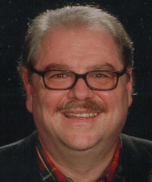
William A. Henderson – Permanent Citizens Advisory Committee to the MTA
William Henderson is executive director of the Permanent Citizens Advisory Committee to the MTA (PCAC), an organization comprising three riders’ councils that were established in 1981 by the New York State Legislature to represent riders of the Long Island Rail Road, Metro-North Railroad and New York City Transit.
He is an author of several transportation reports for the PCAC including “Ladies and Gentlemen: This Is Not a Drill” A Study of Internal and External Emergency Communication Policies at the Metropolitan Transportation Authority and its Affiliated Agencies, In Your Pocket: Using Smart Cards for Seamless Travel, and Where is the MTA on T[ransit] O[riented] D[evelopment].
Prior to coming to the PCAC, Henderson coordinated the housing program of a local Community Development Corporation and has held professional positions in land use, transit, and transportation planning.
Henderson holds a Master of City and Regional Planning degree from Ohio State University and has completed additional graduate coursework at the University of North Carolina at Chapel Hill.

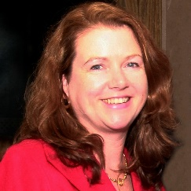
Elisa Picca – LIRR

Elisa Picca is the Chief Planning Officer for the Long Island Rail Road.

As such she has a broad array of responsibilities including: capital planning products such as 20-year capital needs assessment and 5-year capital program development; environmental studies for LIRR system expansion projects; parking program development, fleet and infrastructure strategy development; and Smartgrowth and TOD initiatives including representing the LIRR at key regional forums at the county, town and village level.

Picca has 25 years of experience at the LIRR. Prior to her career at the LIRR, she worked for the NYC Office of Management and Budget.

Picca graduated from Stony Brook University and earned a master’s degree in Policy Analysis and Public Management. She also holds a certificate from the Columbia University Business School’s Executive Education Program.

She is also a member of the Energeia Partnership, Class of 2010 and was named one of LI Business News’ “Fifty around 50” awardees in 2012.

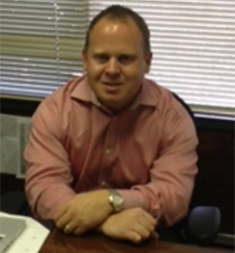
Mike Schoolman – 7BUS

Mike Schoolman is the president of 7BUS, a company that provides frequent service to and from NYC, Ronkonkoma, Melville and Riverhead. Improved high occupancy vehicle access on the Long Island Expressway is an important issue to improve quality of life in the region, and 7BUS encourages commuters and individual travelers to leave their car at home and enjoy the various amenities of the bus including WIFI, power outlets, cup holders and more.

Schoolman is on the board of the Long Island Convention & Visitors Bureau and the Brookhaven Business Advisory Committee.

When not working, he coaches youth soccer and plays tennis competitively. He graduated from Colby College.

