
Water and Wastewater

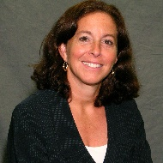
Adrienne Esposito – Citizens Campaign for the Environment, Moderator
Adrienne Esposito is a co-founder of Citizens Campaign for the Environment (CCE) and has worked on numerous environmental campaigns for nearly 30 years. Esposito has crafted campaigns to engage the public on environmental protection issues including upgrading failing sewage treatment systems, protecting of drinking and surface water, remediation of toxic plumes, stewardship of land and water, support for large scale renewable energy projects and reduced pesticide application.
Esposito has also been affiliated with other environmental causes, including the Northport Harbor Water Quality Protection Committee, Carmans River Working Group and Brookhaven National Laboratory Citizens Advisory Committee.
She graduated from Long Island University: C.W. Post.

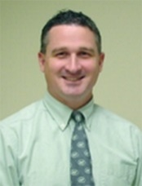
Tim Burns – NYS Environmental Facilities Corporation
Tim Burns was appointed director of Engineering and Program Management for the Environmental Facilities Corporation in June 2009. He administers the technical portion of NY’s Clean Water State Revolving Fund. The state’s Revolving Fund is the nation’s largest and provides financial assistance for water quality projects, both grey and green infrastructure, to protect public health and the environment.
Prior to joining the corporation in February 2002, he was employed by the NYS Department of Environmental Conservation from 1990-2002, where he served in the Region 2 office (NYC) for 10 years addressing water quality issues, his last 2 as the acting regional water engineer.
Burns graduated from SUNY Buffalo and received his master’s in Civil Engineering from the City College of New York. He is a licensed professional engineer in both New York and Vermont.

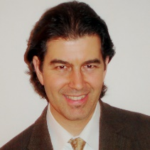
Richard Cisterna – Natural Systems Utilities
Executive vice president – East Region with Natural Systems Utilities, Richard Cisterna has 20 years of water infrastructure development and executive leadership in the water resources and wastewater management field. He has led the development of more than $500 million in capital improvements for municipal and industrial clients.
At NSU, Cisterna is responsible for developing sustainable wastewater reclamation and biogas projects with private ownership or public private partnership structures. He also supports investment management and mergers and acquisitions as part of NSU’s strategic growth planning. He was a partner at an international environmental engineering consulting firm, where he led business development in several geographies and served as the corporate water reuse practice leader.
Cisterna has a M.S. in Environmental Engineering from Stanford University and a B.S. in Civil Engineering from the University of Nevada.

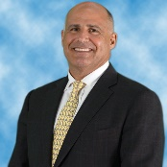
Michael J. Posillico – Posillico
After graduating from Clemson University, Michael J. Posillico began working for his family’s business, Posillico, Inc. – a long-recognized leader in the heavy construction industry. In early 1991, he founded Posillico Environmental (formally known as Blue Water Environmental, Inc.), which specializes in large-scale industrial remediation and marine construction. A “brand” change in 2007 has brought together all of the Posillico enterprises under one name. He manages the Posillico Development companies, which are undertaking some of the most challenging “Brownfield” projects in our region and America. He also serves as chairman of Posillico Environmental and continues to be active in many high profile clean-up projects in the Tri-State region.
Posillico joined the board for the New York League of Conservations Voters (NYLCV) in 2010 and served as the chairman for the Long Island Chapter from 2010-2013; he continues to serves on the NYLCV State Board. Posillioc also serves on the board of Gilda's Club New York, is the past president of the Farmingdale College Foundation and served on the board of Vision Long Island. From 2009-2012, he served on the Long Island Lutheran School Memorial Endowment Foundation.

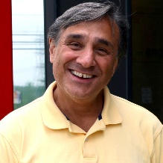
Frank M. Russo – H2M architects + engineers
Frank Russo is the director of Wastewater Engineering for H2M architects + engineers in Melville. He is responsible for the technical planning, design, and construction administration for all of H2M’s wastewater engineering projects. He regularly consults with elected and municipal officials on Smart Growth practices, downtown revitalizations, sewer district formation, and all matters related to the feasibility of sewering areas using conventional and alternative sewer systems.
Russo holds a bachelor’s degree in Civil Engineering from the Rochester Institute of Technology and is a licensed Professional Engineer in New York, New Jersey, Connecticut and Pennsylvania. He is also a NYSDEC Certified Wastewater Treatment Plant Operator.
Russo is also a member of the American Society of Civil Engineers (ASCE), New York Water Environment Association (NYWEA), Water Environment Federation (WEF), National Society of Professional Engineers (NSPE) and is on the Board of Directors for the Long Island Chapter of the Long island Water Environment Association (LIWEA).

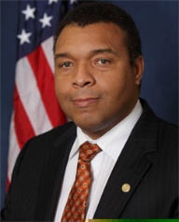
William Spencer – Suffolk County Legislature

Dr. William Robert Spencer, Jr. has years of experience in the medical field, in addition to his more recent role as member of the Suffolk County Legislature.
Dr. William Robert Spencer, Jr. an otolaryngologist, has been at Huntington Hospital since 1997 and opened his own practice, Long Island Otolaryngology & Pediatric Airway, P.C, in 2000. He is a member of the American Board of Otolaryngology, the National Board of Medical Examiners, the American Academy of Pediatrics, The American Academy of Otolaryngology Head and Surgery. He is an officer of the Suffolk County Medical Society, and the American Medical Association.
“Doc” is serving in his second term in Suffolk County’s 18th Legislative District. The first physician to serve in the legislature, he is serves as the chairman of the Health Committee. From within the legislature, Spencer has requested a dedicated fund to improve the Wastewater Treatment Collection System in Northport and has worked to find new and more efficient sewage treatment technologies to protect drinking water and health. He also sponsored a resolution to ban smoking in county parks, furthering his commitment to environmental health in Suffolk.
Spencer has long been active in his community through his church and is pastor of Willow Manor Fellowship in Centerport.
Doc attended Wesleyan University and the University of Connecticut School of Medicine. He completed his residency in Otolaryngology at the New York Eye and Ear Infirmary and was a fellow at the University of Miami in Pediatric Otolaryngology. Doc has published 16 peer-reviewed journal articles.

