
August 20, 2010

Peter Kiernan
Governor's Office of
Chief Counsel
Executive Chamber
State Capitol
Albany, New York 12224

Dear Mr. Kiernan:

Last November, at the Vision Long Island Smart Growth Summit, Governor Paterson eloquently asserted that “Smart Growth is the pressing progress of the future rather than the comfort of the present.” The Governor also noted that “not making smart growth choices” may explain why 49 states have declining revenues. I was impressed by the importance he attributed to smart growth, and by the overall force of his convictions regarding smart growth, land use, development and fiscal rectitude. We have been pleased by his ongoing commitment to these issues as evidenced by the actions of his Smart Growth Cabinet.

Earlier this summer, the New York State Legislature passed a bill that addresses this cluster of issues in a fundamental way. You now have on your desk, the Public Infrastructure Priority Act (A8011B/S5560B). This bill instructs State Agencies, Authorities and Public Corporations to align their spending on infrastructure with stated smart growth criteria. These agencies must form advisory committees that include environmental and community stakeholders. The agencies must also issue written Smart Growth Impact Statements in regard to their project choices and that includes issuing written justifications for projects deemed vital that do not meet smart growth criteria.

On behalf of the 39 business, civic and environmental organizations in the Empire State Future coalition and our partners, I urge your administration to sign this bill. Doing so will help to realize the vision and pragmatic approaches so articulately expressed in Long Island and elsewhere. Your signing this far-reaching bill will significantly advance a process whereby:

New Yorkers get the best possible bang for the buck from our limited infrastructure money.

State expenditures for infrastructure projects increasingly become investments toward an economically and environmentally sustainable future – whether on main streets, in town centers, our rural or urban areas.

New York stops using public funds to add infrastructure in green fields, destroying habitat, threatening species and water supplies, when the state and its localities cannot afford to properly maintain the essential water, sewer, road, rail and bridge infrastructure we already have.

New York focuses on fix-it-first infrastructure so that our agricultural economy, our subways and our wastewater treatment plants protect our environment and keep us healthy and prosperous.

Our communities do not condemn us to use our cars for everything we do – spewing green house gases, and burning up oil that we produce at risk, or import from those who are too often our enemies.

Our communities become more equitable and environmentally just.

The needs of all users of our public spaces from parents with strollers to the disabled are met in road and street design.

The communities we strengthen and build here in New York will better meet the housing and service needs of our state’s seniors and the large cohort that, like it or not, will soon be seniors.

State public health concerns in regard to diabetes, obesity and heart disease can be met by designing and building communities where walking and riding bicycles is safe and practical.

For the many profound and important reasons listed above, each one worth re-reading, we, the members of the Empire State Future and its partner organizations urge you to sign this course-changing bill which the New York State Assembly supported 138-2 and that the NYS Senate passed 56-2.

Sincerely,
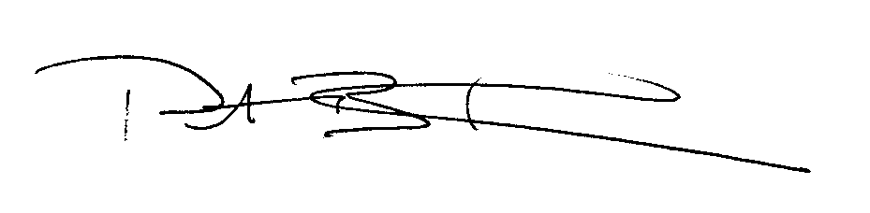
Peter B. Fleischer

Executive Director
Empire State Future
pfleischer@empirestatefuture.org
www.empirestatefuture.org
917-443-4248

